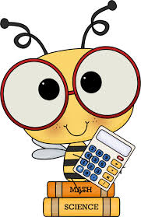



**Operations & Algebraic Thinking**

**~** I understand that multiplication is related to repeated addition.

**~** I understand division is dividing a group or amount into smaller,

equal groups or amounts.

**~** I can apply the properties of addition and multiplication.

**~** I understand how **+** & **-**  and **X** & **÷** are related in fact families.

**~** I can find missing numbers in  **+, -, X**  and  **÷**  equations.

**~** I can multiply and divide within 100 easily and quickly.

**~** I can identify arithmetic patterns and explain them.

**~** I can memorize all the multiplication facts.

**~** I can solve word problems by using **+, -, X, ÷**, telling time,

units of measure, and geometry.

**Measurement & Data**

**~** I can tell time to the nearest minute.

**~** I can measure liquids and solids using the appropriate unit.

**~** I can show information with a drawing, bar graph, or plot line.

**~** I can find the perimeter and area of polygons by measuring,

using square units, or using multiplication and addition.

**Numbers & Operations in Base 10 and Fractions**

**~** I can round numbers to the nearest 10 and 100.

**~** I can add and subtract 2- and 3-digit numbers.

**~** I can multiply any 1-digit number by any multiple of 10.

**~** I know fractions are equal parts of a shape, object, or group.

**~** I can place fractions on a number line.

**~** I can show that two fractions are equal with a model or picture.

**~** I can use >, <, and = signs to compare two fractions.

**Geometry**

**~** I can place shapes into categories based on their attributes.

**~** I know that polygons with four sides and angles are called

quadrilaterals, and I can draw examples of them.

**~** I can divide a shape into equal parts and show each part as a

fraction of the shape.

**Almond-Bancroft**

**Elementary School**



**“I CAN”**

**Statements**

What should you expect your child to learn

in third grade? This brochure contains the main

academic learning goals for student achievement

by the end of third grade.

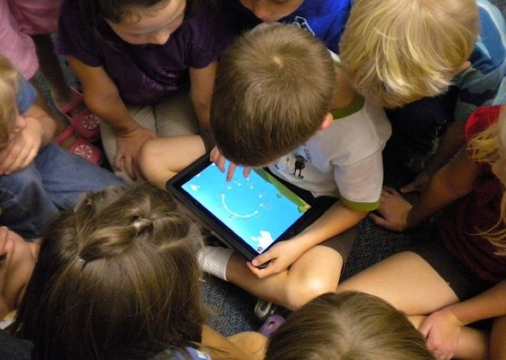

**Almond-Bancroft School District Almond, WI**

**What are “I Can” Statements?**

**“I Can” Statements are learning goals that are set at the students’ grade level. They are written in “kid-friendly” language so students know and can better focus on what they will be learning during a lesson or unit of study. “I Can” Statements allow students to participate in assessing their own progress and help teachers make adjustments in instruction that maximize student learning opportunities.**



**~** I can learn from what I read.

**~** I can ask and answer questions about what I read, and I can

find evidence for my answers in the text.

**~** I can find the main idea, identify the important details, explain

how the details support the main idea and summarize the text.

**~** I can use text features and illustrations to help me understand

the text.

**~** I can identify the plot elements of a story: setting, events,

problem, and solution.

**~** I can describe the characters and explain how their actions

affect the story.

**~** I can retell the events of a story in correct order.

**~** I understand the difference between literal and nonliteral

language.

**~** I understand the difference between what I think, what the

characters think, and the author’s point of view.

**~** I can make text-to-self, text-to-text, and text-to-world

connections when I read.

**~** I can use decoding skills and context clues to read and

understand words I don’t know.

**~** I can read texts at the upper second to third grade level

correctly and with appropriate speed.

**~** I can use different strategies to help me understand what I read.

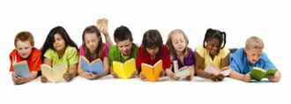



**~** I correctly spell the words I’ve studied whenever I write them.

**~** I can explain how the parts of speech are used in sentences.

**~** I can use a variety of sentences in my writing.

**~** I can use capital letters and punctuation marks correctly.

**~** I use what I know about grammar when I write and speak.

**~** I can use linking words (and, also, but) and time words (before,

during, after) to connect my ideas.

**~** I can choose interesting words and phrases to help others

understand what I mean.

**~** I can write to share my opinions, relate information, tell a

story, and complete assignments.

**~** I can begin my writing with an introduction and end with a

concluding statement or paragraph.

**~** I can stay focused on the topic, organize my thoughts in order,

and state my ideas and information clearly.

**~** I can include reasons that support my opinions, details and

facts that explain my ideas, and illustrations that make it easier

to understand what I have written.

**~** I can edit my work to correct mistakes and make my writing

clear and interesting.

**~** I can gather information on a topic and evaluate the accuracy

of my sources in order to conduct a research project that is

supported with evidence.





**~** I can follow the rules for discussions.

**~** I can stay on topic during discussions, share

what I know, and explain my thinking and ideas.

**~** I can ask and answer questions about information I hear and

see during a presentation.

**~** I use what I know about grammar when I speak.

**~** I speak so others can hear me and use complete sentences so

that they understand what I am saying.

**~** I can summarize when I share what I have read, heard, or seen.

