While choosing an apartment, it was very difficult to accommodate both Jeff and Stephany with their jobs. Renting an apartment with room to function, closet space, and access to the city to buy necessities is Jeff and Stephany’s main priorities. Their new apartment is located in Schofield, WI. The cost of the apartment was a major attribute to choosing an apartment. Stephany and Jeff wanted a cozy apartment that was suitable for them and they found an affordable and family friendly apartment.

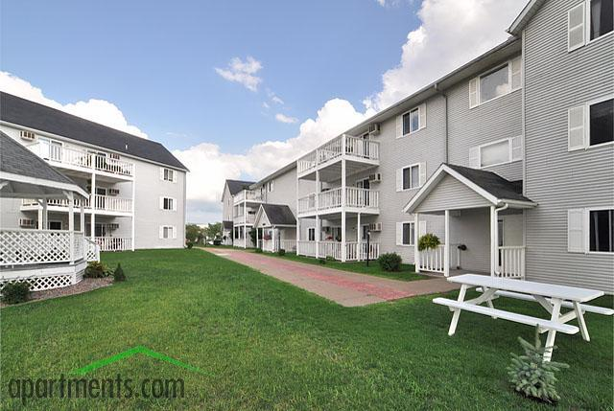

Their apartment is seven hundred and fifty six square feet which consists of one bedroom, one bathroom, and costs $550 a month. The deposit consists of one month’s rent. The apartment features air conditioning, cable or satellite, bbq or picnic area, free wireless internet, storage space, sundeck, elevator, laundry carpeting, ceiling fan, disability access, dishwasher, disposal, large closets, microwave, patio or balcony, refrigerator, a lake view, window coverings, and a yard. Also the apartment features parking, detached garage, utilities such as gas, sewage, trash, and water. For pets there isn’t an extra charge for their dog Pheonix. Everything that Jeff and Stephany want is featured in this apartment and they will start their lives at the Lake Pointe Apartments.

