Apartment

Some of the things we are looking for in an apartment are size, low price and nice location. We would like a two bedroom apartment with one or more bathrooms. A roomy kitchen is also something that we would prefer. Having a dishwasher is not a priority because Audra does all the dishes. A deck or patio would be nice but it is not needed. Eight hundred dollars is about the maximum amount of money we want to spend.
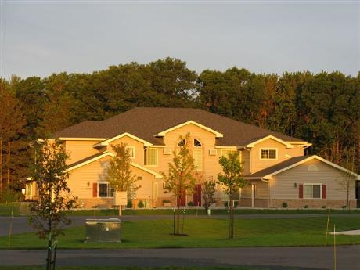
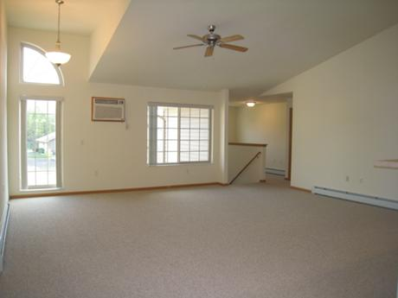

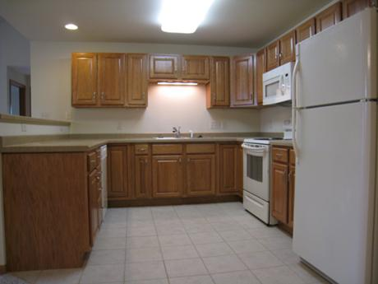

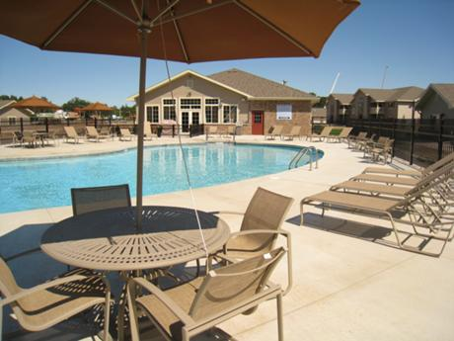

The housing complex we chose was the Windsors in Plover. It is 1085 square feet and has a 24 hour fitness center, pool, and a community recreation room. Included is a washer and drier, microwave, AC, walk in closets, and a dishwasher. Everything we want is included but the price is a little more than we wanted at $835 a month with half a month’s rent down.

