Apartment
Richard and Britney want to have a two bedroom place and one bathroom. It should coast $600 a month and have working appliances. The apartment will be in Stevens Point. 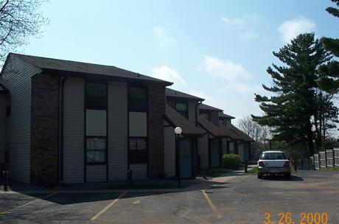

The apartment is 900 square foot it coast five hundred and fifty dollars, located in Stenens Point , two bedroom, one bathroom, dish washwer, refrigerorator, air contidtioning, carpitiong, ceiling fan. No pets allowed.

