Buying a Home

Rabe and Rachel bought a one story house on Bukolt Avenue in Stevens Point. It is 584 square feet, it has two bedrooms and one bathroom. The lot size is 39X150 feet with a two car garage, but it was a steal at only 34,900 dollars. I know what you are thinking, that is a low price, and it is. The school district is P.j. Jacobs which is a very prestigious school for their child Alexander. The property taxes are 1,004.00 dollars a year. They like that it is very affordable and close to where they work. They dislike how small it is and would of rather lived in the country. It was cheap cheapcheap and cute that is why they picked it.

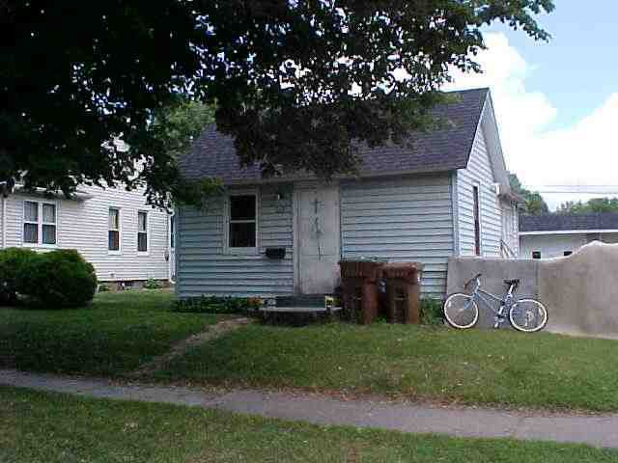

Rabe and Rachel have decided on the 15-year mortgage loan. The payment is only 306.51 dollars a month and with their net income it will easily fit in their budget. They want to pay it off fast that way they can save up for a better house when they are older. With the 15-year loan they will end up paying 55,172.05 dollars at the end of their contract which is 31,034.06 dollars cheaper in the long run then the 30-year loan.

