The home we picked had 3 rooms, 2 bathrooms, and a spacious back yard. The 3 rooms were perfect as we want to adopt one more child. We wanted at least the 2 bathrooms so there was one bathroom for the children and one for Jon and me. All this for only $109,900! What a bargain! The schools attended would be McKinley for elementary and Ben Franklin for middle school. When they move onto high school we will pay for private school at Pacelli. The property taxes were are at $2,852.00 a year. We easily fit this into our budget.
Jon’s favorite thing about the house was the enormous deck. This provided him and Richard with hours of entertainment grilling out and flipping hamburgers in the air. My favorite part of the house was the fireplace and walk-in closets. The thing we disliked was the red carpet that was there when we moved in. We later tore it out and replaced it with a plush, gray colored carpet.
The major factors in our decision were the price, size, location, and the size of the yard. We needed something to fit our budget and this house was a lot for the money. It was also just the right size and conveniently located right in Stevens Point, where we both work. And the size of the yard was important because we want our children to practice a healthy lifestyle and refrain from watching TV often.

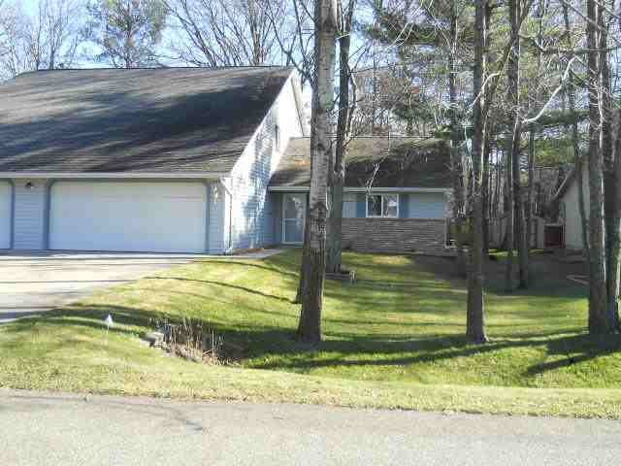

We chose the 15-year mortgage term because it had the lowest interest rate, we end up paying the least in the long run, and the monthly payment was only a few hundred dollars more than the 30-year mortgage.

