Buying a Home

Richard and Brittney needed to buy a house for there going family but since we don’t have that much money we just went with the cheapest house Richard could find witch is still a very nice house. It is a four room house, one bathroom, and coast Fifty Nine thousand nine hundred dollars. It is located in the Stevens Point school district so the kid will be sent to McKinley for elementary school and Ben Franklin for high school. We really like that it has four rooms so we can have guest over. Brittney doesn’t like that there is no garage. The house was such a good deal we had to buy it plain and simple.

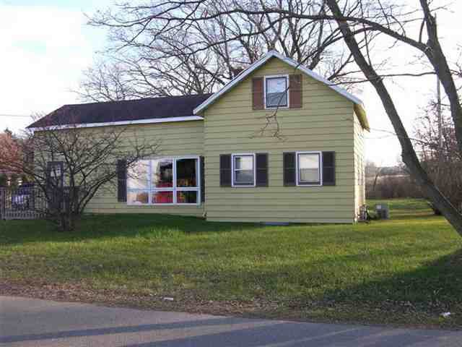

We decide to go with the thirty year mortgage so we can have a little more money to spend on fixing the house up instead of spending it on the mortgage each month.

SECTION 5: BUYING A HOME IN STEVEN’S POINT AREA

Once you have found a home, fill in the two “bordered” charts below and then you will paste them in the appropriate place in your report.

Property Taxes per Year $____________$1,799.00______ (as shown on listing)

Property Taxes per Month $_______149.92____________ (Taxes per year divide by 12)

Homeowner’s Insurance per Year $________719.60__________ (Assessed Value X 0 .25%)

Homeowner’s Insurance per Month $___________59.67_______ (Divide by 12)

Credit Score Table: (use your average credit score to find your interest percentage rate)

15 year loan 20 year loan 30 year loan
800 + 5.5 % 5.75 % 6.0%
700-799 5.85% 6.25% 6.375%
600-699 6.25% 6.5% 7.0%
500-599 7.25% 7.5% 9.0%

Assignment~

Use any online mortgage calculator to obtain the answers needed for the table below (Fill the table in completely):

Term of Loan | Monthly Payment | Monthly Mortgage  (Monthly Payment + Property Tax + Homeowner’s Insurance) | Total Amount Paid Throughout Entire Term  of Mortgage
15 Year Mortgage | 538.45 | 2238 | 96,655.71
20 Year Mortgage | 488.56 | 2188.56 | 110,033.87
30 Year Mortgage | 384.59 | 2084.59 | 138,453.47

