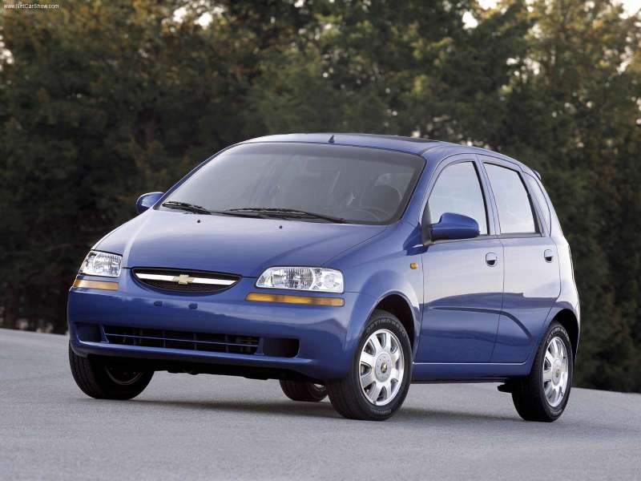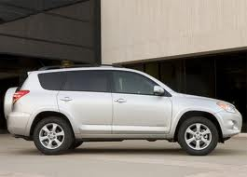
Our family bought two cars this year. The first was a 2004 used, blue, Chevrolet Aveo. We choose this vehicle because it gets good gas mileage and is a great family car ecspecially for our growing family. Our second vehicle was a 2009 used, silver, Toyota RAV4. This vehicle is much like the Aveo because it has lots of room and gets good gas mileage and is big enough for a growing family. Both cars should work for us very well.
We choose to take out the three year loan. We would be paying $437.76 a month which is affordable for our family and we would only be paying $1,801.69 in interest. Compared to a 6 year loan for us which would be $3668.51 in interest. We think this choose is smart and will be better for us in the long run.

