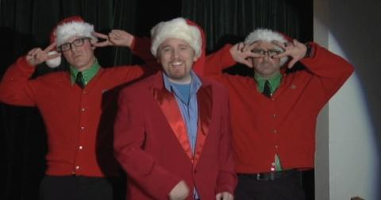
OUR HONEY MOON HOME FOR THE WEEK

The Dan Band, Our reception entertainment, all dressed up for us as well.

