To Whom it May Concern,

My name is Danielle Stiebs, the K-12 Business Education teacher here at Almond-Bancroft. This year the district has choosen to move formal keyboarding instruction from the middle school, down into elementary school. I will be teaching 3-5 grade each for one quarter every year. I am so excited for this opportunity as building proper technique and fondational skills is essential for student success as they are each “digital citizens” in the world they live in both in and outside of school.

There were two driving forces to move it down to the elementary level this year, one is the new Department of Public Instruction (DPI) Business & Information Technology Standards that states: IT1.a.1.e: Demonstrate the correct finger placement and reaches. (Recommended minimum: 5 wpm x grade level). as as well as the evolution of the standarized test. The Smarter Balanced Assessment the students shall be taking is completed 100% on the computer and students will need to key in their responses to many of the questions.

I have attached several pieces of information to help you see the many benefits of keyboarding, how the Keyboarding class is organized and what my expectations are of the students. Please take a moment to go over each of the attached and contact me if you have any questions or concerns.

Danielle Stiebs

Business Education Teacher

Yearbook & FLBA Advisor

[dstiebs@abschools.k12.wi.us](mailto:dstiebs@abschools.k12.wi.us)

715-366-2941 etx. 314

Attachments:

1. Benefits of Keyboarding
2. Computer Lab Expectations
3. Proper Technique Diagram
4. Homework Assignment
5. Online Keyboarding Resources

Benefits of Keyboarding

## Our goal is to become speedy typers using the “touch” method.

## The success of our Keyboarding program depends on the combined efforts of:

* Business Education Teachers For direct instruction of finger reaches, and to provide practice drills at school and at home.
* Classroom Teachers For promoting proper technique while students work on projects in classrooms or in the open lab.
* Parents To encourage proper technique and promote key finger reach practice when students complete practice assignments at home.

## The benefits of introducing keyboarding at this time are:

1. Improvement in the language arts areas—reading, spelling and writing ability.
2. Improvement in student attitude towards writing, less frustration in looking for keys.
3. Improvement in the usage of proper keyboarding techniques, eliminating the formation of bad habits.
4. Improvement in integrating keyboarding with all subject areas.
5. Improvement in motivating all students towards doing school work.
6. Improvement in the efficiency of using the computer as a writing, editing and computing tool maximizing classroom time.
7. Laying the foundation of life long skill in a technological society.
8. Meeting new Department of Public Instruction’s Academic Standards.

Computer Lab Expectations

|  |  |  |
| --- | --- | --- |
|  | Keep your hands and feet to self | |
|  | Food and drinks left at the door | |
|  | | Save your work &  Recycle what you don’t need |
|  | Treat all people with respect | |
|  | Treat all school equipment with respect | |
|  | Hands on head when instructions are being given | |
|  | Keep a positive attitude | |
|  | Keep working toward your goals | |

Proper Technique Diagram

1. Sit up Straight
2. Feet Flat on the Floor
3. Belly button lined up with “B” key
4. Elbows have an “L” curve
5. Keep wrists straight
6. Fingers curved & on home row
7. Eyes on copy, not on keyboard

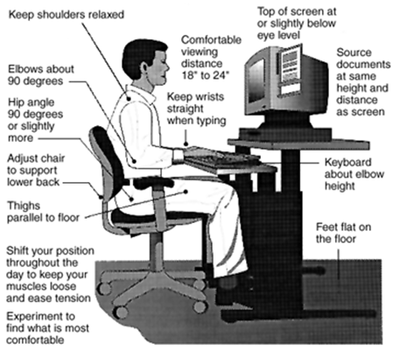

Sample Homework Assignment

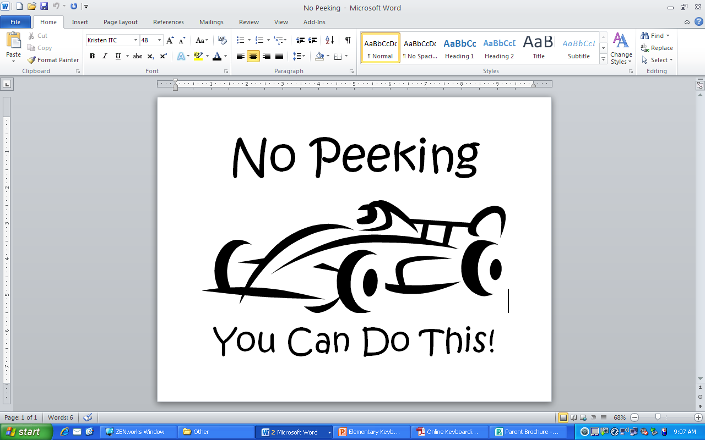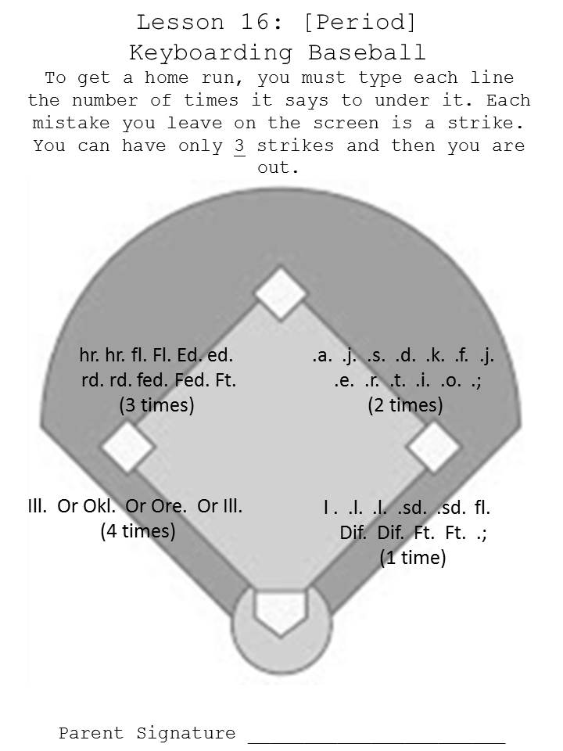

All homework is to be signed by a parent or other family member, teacher, boys and girls club staff, etc. to indicate that it has been completed. Please note the directions for the number of times each line is to be keyed (typically 3 times to build muscle memory).

This sheet will be going home with students to be placed over their hands while completing their home. If this sheet is lost, an alternative sheet, folder, piece of cloth, etc. could be used to prevent the student from looking down to locate the keys.

Online Keyboarding Resources

I have several links to both lessons and games on my homepage including and in addition to these listed below. To get to my home page, hover over [Secondary School], select [Business Education], and then on the left side [Keyboarding].