Retirement

Jeff and Stephanie are starting to plan their retirement. After beginning their life together they realize how much everything costs. If they do not start planning for the future now they will be deep in a hole when they become to be older. Stephanie has made it clear that she enjoys her job and wants to keep doing it for a long time. Around the age of 105 she plans to retire. While Jeff enjoys his job, he is not going to work as long as Stephanie is planning on. He will retire between the ages of 65-70. He will probably pick up a part-time job after retirement. To be ready for the future Jeff and Stephanie are putting money away for retirement.
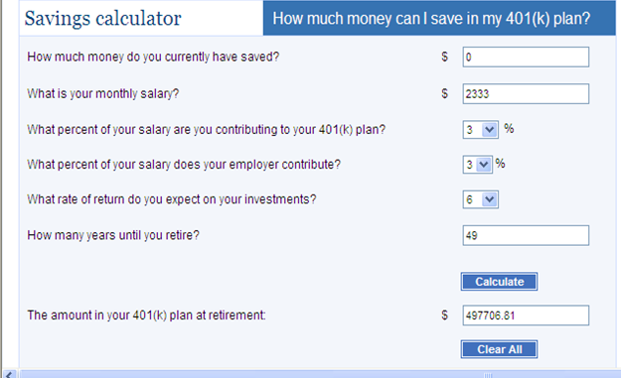
Stephanie used the 401(k). We chose 3% because that was thought to be appropriate amount. 49 years was how years until retirement because Stephanie said that she said she would work until 80.

Jeff used the retirement option of the Traditional IRA. The traditional IRA gave out more money for retirement than the Roth IRA did. Because of this the traditional IRA is the best option. Jeff figures that he will work for another 35 years which is why 35 years was put in.

Jeff and Stephanie are ecstatic about the amount saved up for the retirement life. They think that they will be able to live comfortably with this amount. Considering how neither of them are thinking about retiring early this amount should be more than plenty. If things start to come up the two of them can always add more to their retirement savings. But for now the money saved should be enough to last them awhile.

