Rabe and Rachel will be having their wedding ceremony at The Red Bridge in Waupaca. The date of the ceremony is set for Friday, May 6th 2012. The ceremony will be held outside near the water. Both groom and bride have big families and are expecting most of them to be there. This means the
wedding will be big and extravagant. Guru Pitka will be performing the service.
Rabe’s best man will be Tony Vauthier. Tony is Rabe’s brother in law and dear friend. The other two groomsmen will be Tyler Meddaugh and Lucas Meddaugh. Both are close friemds of the groom. Rachel’s Maid of Honor will be Stephanie Rodriquez. Stephanie has been a lifelong friend of Rachel’s and they have always been like sisters. Deanna Fellela and Amy Keyes will be the other two bridesmaids. Rachel’s Nephew Nicholas Keyser will be the ring bearer and Rabe’s cousin Mecina Meddaugh will be the miniature bride.
Take a look at our chart: Wedding Preparation and cost to see our budget preparation for our wedding.
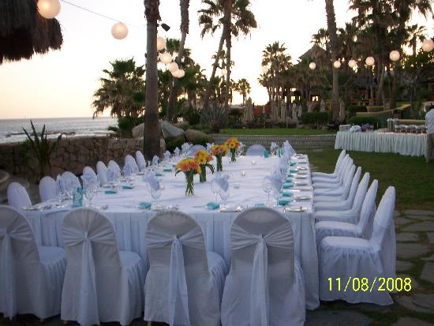
Rabe and Rachel’s weddings total cost came out to $17,625. They both think the wedding could have been less but they think it is a reasonable price for their dream wedding. They don’t think it will too difficult for them to pay for it on their own. But both Rachel’s and Rabe’s parents are willing to help pay for the wedding if need be.
Rachel’s parents both said they would help pay for the entertainment and some of the activities at the reception. Rachel’s mother would also like to buy her dress for her. Rabe’s parents agreed to help pay for the photographer and the money to rent out the reception hall. Rabe’s and Rachel’s parents are happy to help their children have the dream wedding they have always wanted.

